**A Project Report**

**On**

**CRM Application that helps to Book a Visa Slot-(DEV)**

**Submitted In accordance with the requirement for the degree of**

**BACHELOR OF TECHNOLOGY**

**Submitted by:**

**KUNAPAREDDY YASASWINI DEVI (218X1A1220)**

**NISSANKARARAO VENKATA TARUN (218X1A1265)**

**GOLI VENKATA RAMANJI (218X1A1210)**

**TADIBOINA VENKATA SURENDRA GOPAL (218X1A1239)**



**DEPARTMENT OF INFORMATION TECHNOLOGY**

**KALLAM HARANADHAREDDY INSTITUTE OF TECHNOLOGY  
(AUTONOMOUS)**

**Approved by (AICTE, New Delhi; Permanently Affiliated to JNTU KAKINADA)**

**Accredited by NAAC with an ‘A’ Grade**

**NH – 16, Chowdavaram, Guntur – 522019 (A.P)**

**ACADEMIC YEAR: 2024-2025**

**Project overview**

The Salesforce CRM-based Visa Slot Management System is a comprehensive solution designed to streamline the visa appointment booking process for both applicants and processing agencies. Built on Salesforce’s robust CRM platform, this system allows applicants to register, view available visa slots, and book appointments with ease. It provides automated notifications and reminders via email and SMS, ensuring applicants stay informed about their bookings.The system integrates with payment gateways for secure fee transactions and leverages Salesforce’s security features to protect applicant data. By centralizing data and automating key processes, the solution improves operational efficiency, enhances communication, and provides real-time insights, ensuring a seamless visa booking experience for all users

**Objectives**

* **Automate Visa Slot Booking:**

Automate the process of visa slot booking and management to reduce manual intervention, providing a more efficient and convenient system for both applicants and visa processing agencies.

* **Improve Customer Experience:**  
  Provide applicants with an intuitive, easy-to-use platform for booking visa slots, ensuring timely notifications, reminders, and a seamless booking experience across devices.
* **Track Appointment Status:**  
  Provide real-time updates on the status of visa applications.
* **Manage User Data Securely:**

Store applicant details safely and ensure compliance with data protection regulations.

#### **Methodology**

* **Requirements Gathering:**Conducted surveys and discussions with visa applicants, embassy officials, and agencies to understand their needs.
* **System Design:**  
  Designed a CRM-based solution with modules for appointment booking, tracking, and communication.
* **Implementation:**  
  Developed and tested the application using CRM features such as automated workflows, notifications, dashboards, and reports.
* **Deployment:**  
  Rolled out the application for public use, ensuring scalability and user accessibility.

**Salesforce Key Features And Concepts Utilized**

**Key Features:**

* Salesforce User Registration & Profile Managemen:
* Custom Visa Slot Availability Tracking
* Booking Management via Salesforce
* Automated Notifications & Reminders
* Payment Integration via Salesforce
* Admin Dashboard & Custom Reports

**Concepts Utilized:**

* Custom Objects and Fields – Created objects for Customers, Orders, Transactions, and added custom fields to store relevant data.
* Lightning App – Developed a custom Lightning App for easy navigation and a streamlined user experience.
* Tabs – Configured tabs for quick access to Customers, Orders, and Reports.
* Global Picklist – Standardized values across multiple objects (e.g., Order Status: Pending, Shipped, Delivered).
* Page Layouts – Customized layouts to display relevant fields and sections based on user roles.
* Record Types – Created different record types for Customer Accounts, Order Categories, and other business cases.
* User Adoption – the process of customers or new users getting used to a product or service, it makes a task,ordering food or creating an account, easy.
* Reports and Dashboards – Implemented Salesforce Flows to automate processes such as order approvals and follow-up emails.
* Apex Triggers – enable you to perform custom actions before or after changes to Salesforce records, such as insertions, updates, or deletions

**Detailed Steps to Solution Design**

**Creating Developer Account:**

Creating a salesforce developer org for <https://developer.salesforce.com/signup>.

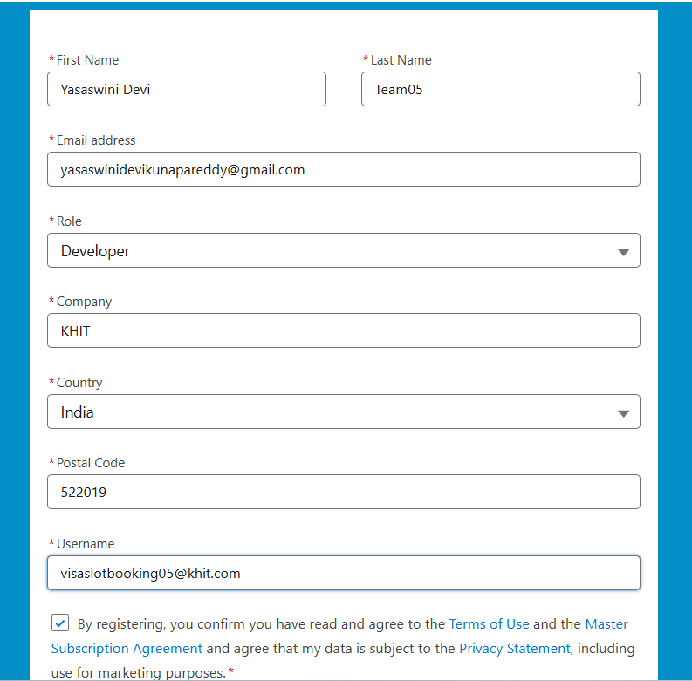

**Account Activation**

After creation we have got accepted mail to verity the account.

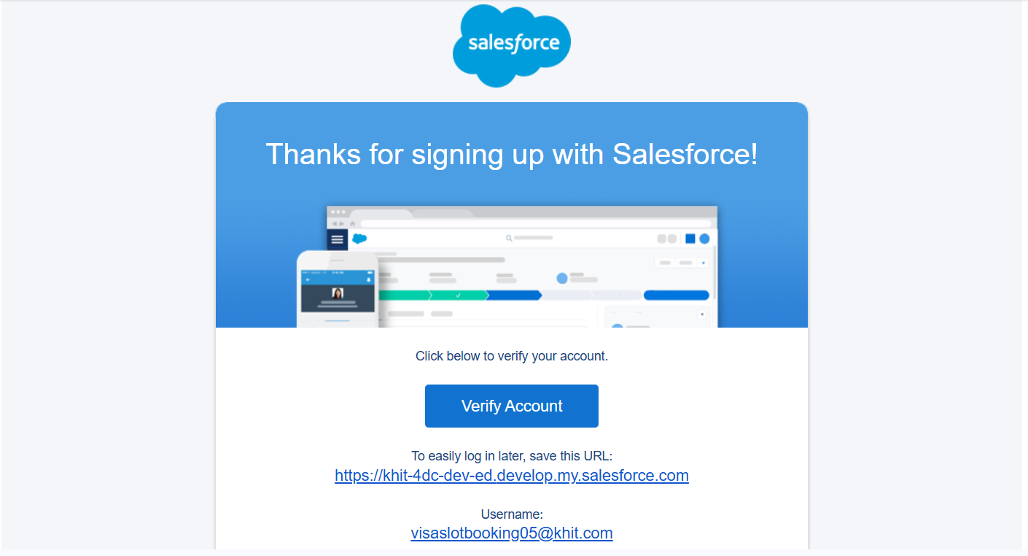

After clicking on the verify account, We have to set a password for the org and use it of the project.

After successfully login to the account, Then you will redirect to your salesforce setup page.

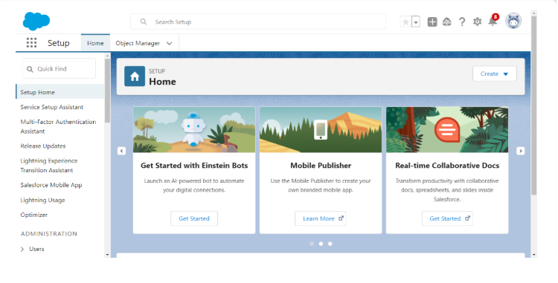

**Object Creations**

What Is an Object?

Salesforce objects are database tables that permit you to store data that is specific to an organization. What are the types of Salesforce objects.

They are two types of objects:

1.Standard Objects.

2. Custom Objects.

**Standard Objects:**

Standard objects are pre-defined by Salesforce and form the core foundation of the CRM system. These objects are designed to store common business data that organizations typically use in sales, marketing, and customer support processes. Examples include Accounts, which represent companies or organizations, Contacts, which store details of individuals associated with accounts, and Opportunities, which track potential sales deals. Standard objects also include Leads (potential customers) and Cases (customer service issues).

**Custom Objects:**

Custom objects, on the other hand, are user-defined objects created to store data specific to an organization's unique needs. While standard objects cover general CRM use cases, businesses often require additional fields and objects to manage industry-specific processes. For instance, a hospital might create a custom object called Patient__c to track patient records, while a construction company may use Project__c to manage project details. Custom objects come with their own fields, relationships, page layouts, and security settings, allowing businesses to tailor Salesforce to their workflows.

**Creation of Passport Object:**

To create a passport object we should go to setup in a salesforce org.

Follow the steps below to create a custom object in Salesforce:

1. From the Setup page, click on 'Object Manager'.
2. Click on 'Create'.
3. Click on 'Custom Object'.
4. Enter the label name: Passport.
5. Enter the plural label name: Passports.
6. Enter the Record Name Label and Format:
   * Record Name: Passport Number
   * Data Type: Text
7. Enable ‘Allow Reports’.
8. Enable 'Allow Search'.
9. Click 'Save' to complete the process.

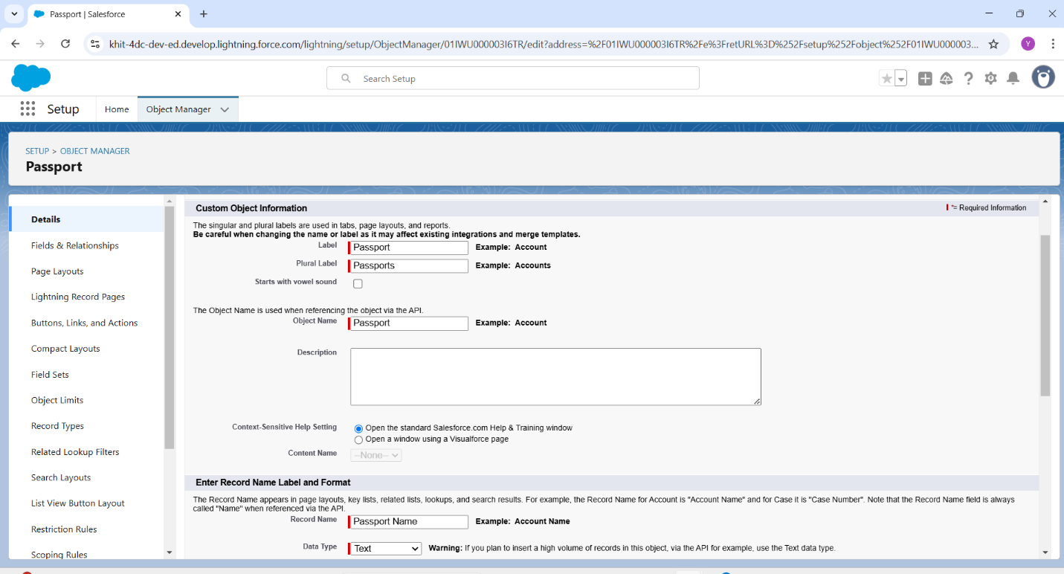

**Creation of Visa Slot Object:**

To create a visa slot object we should go to setup in a salesforce org.

Follow the steps below to create a custom object in Salesforce:

1. From the Setup page, click on 'Object Manager'.
2. Click on 'Create'.
3. Click on 'Custom Object'.
4. Enter the label name: Visa Slot.
5. Enter the plural label name: Visa Slots.
6. Enter the Record Name Label and Format:
   * Record Name: Visa Slot Number
   * Data Type: Auto Number
   * Display Format: V-{00000}
   * Starting Number: 1
7. Enable ‘Allow Reports’.
8. Enable 'Allow Search'.
9. Click 'Save' to complete the process.

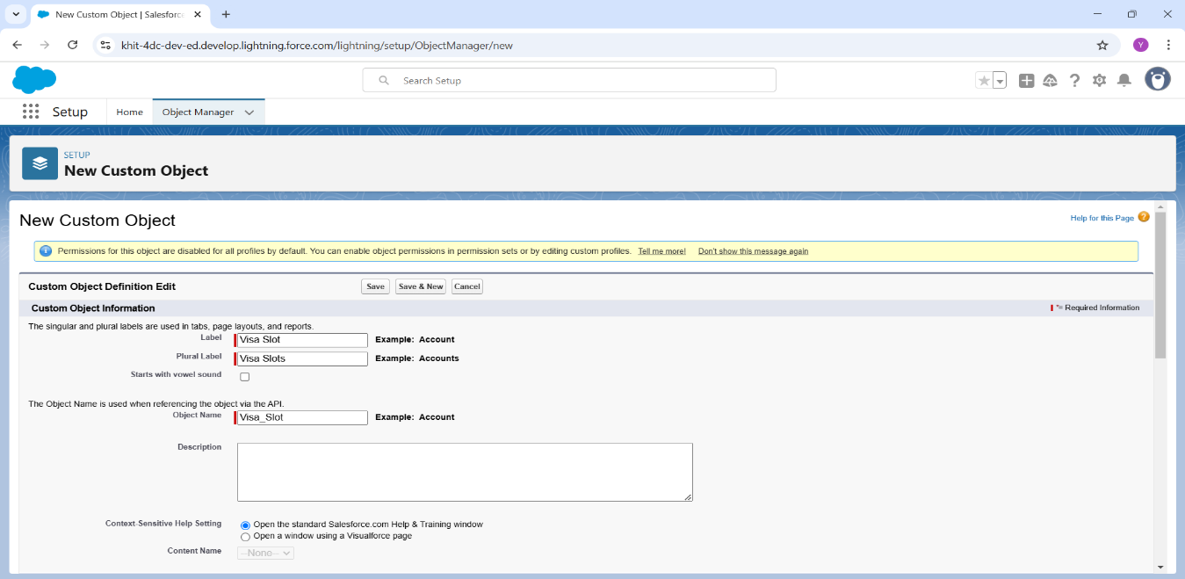

**Creation Payment Object:**

To create a payment object we have to follow this steps

1. From the Setup page, click on 'Object Manager'.
2. Click on 'Create'.
3. Click on 'Custom Object'.
4. Enter the label name: Payment.
5. Enter the plural label name: Payments.
6. Enter the Record Name Label and Format:
   * Record Name: Transaction Id
   * Data Type: Auto Number
   * Display Format: TId-{00000}
   * Starting Number: 1
7. Enable ‘Allow Reports’.
8. Enable 'Allow Search'.
9. Click 'Save' to complete the process.

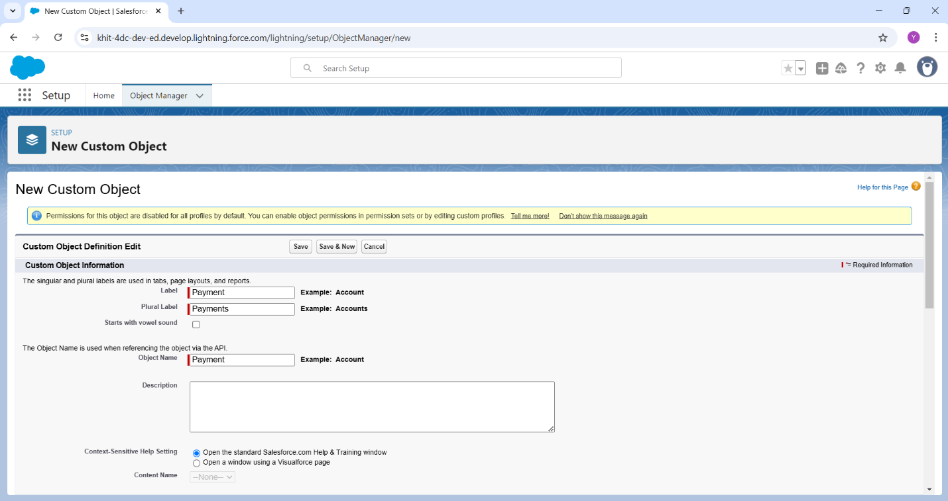

**TABS**

Tab: A tab is like a user interface that used to build records for objects and to view the records in the objects.

Tabs basically categorize into 4 different sections-

1. Standard Object Tabs
2. Custom Object Tabs
3. Web Tabs
4. Visualforce Tabs

**Creating a Custom Tab:**

**Custom Tab for Passport Object:**

Follow the steps below to create a custom tab for the Passport object in Salesforce:

1. Go to the Setup page.
2. Type 'Tabs' in the Quick Find bar and click on 'Tabs'.
3. Under 'Custom Object Tabs', click on 'New'.
4. Select the Object: Passport.
5. Select the Tab Style.
6. Leave all default values.
7. Click Next, Next.
8. Click 'Save' to complete the process.

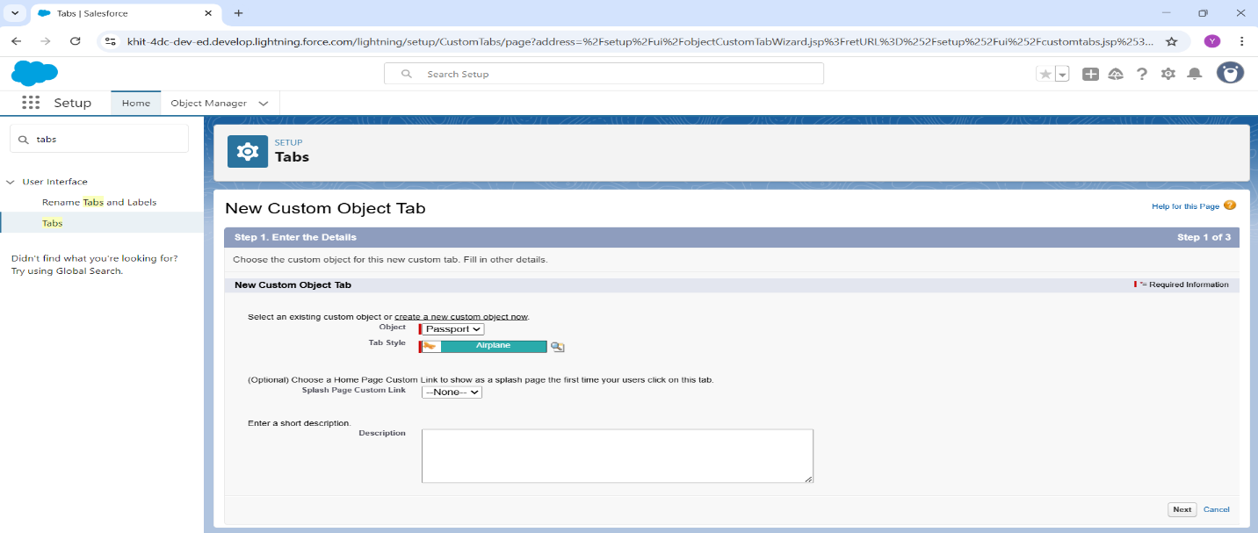

**Custom Tab for Visa Slot Object:**

Follow the steps below to create a custom tab for the Visa Slot object in Salesforce:

1. Go to the Setup page.
2. Type 'Tabs' in the Quick Find bar and click on 'Tabs'.
3. Under 'Custom Object Tabs', click on 'New'.
4. Select the Object: Visa Slot.
5. Select the Tab Style.
6. Leave all default values.
7. Click Next, Next.
8. Click 'Save' to complete the process.

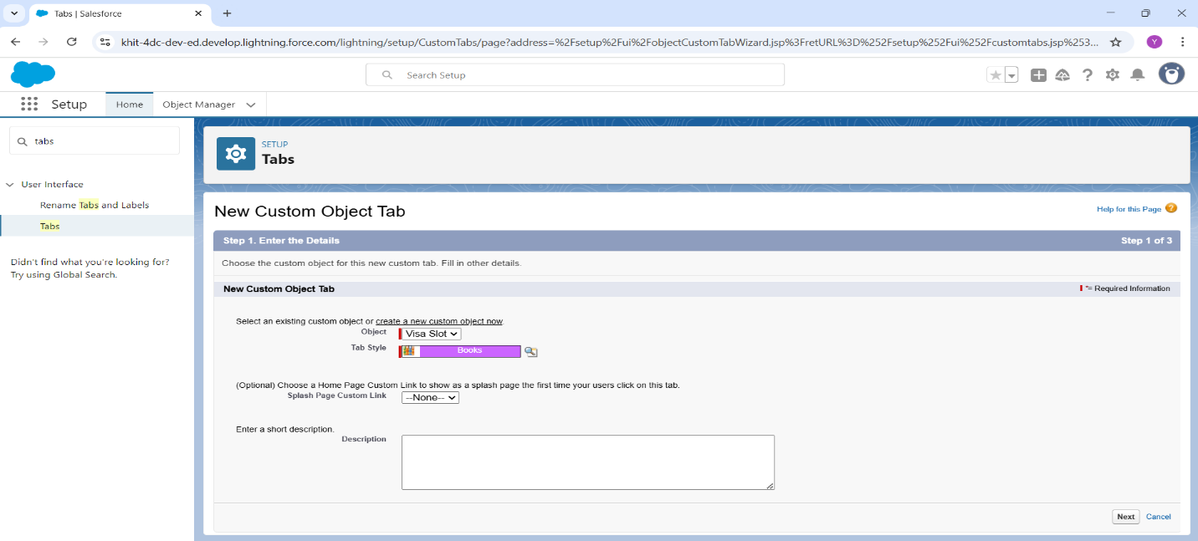

**Custom Tab for Payment Object:**

Follow the steps below to create a custom tab for the Payment object in Salesforce:

1. Go to the Setup page.
2. Type 'Tabs' in the Quick Find bar and click on 'Tabs'.
3. Under 'Custom Object Tabs', click on 'New'.
4. Select the Object: Payment.
5. Select the Tab Style.
6. Leave all default values.
7. Click Next, Next.
8. Click 'Save' to complete the process.

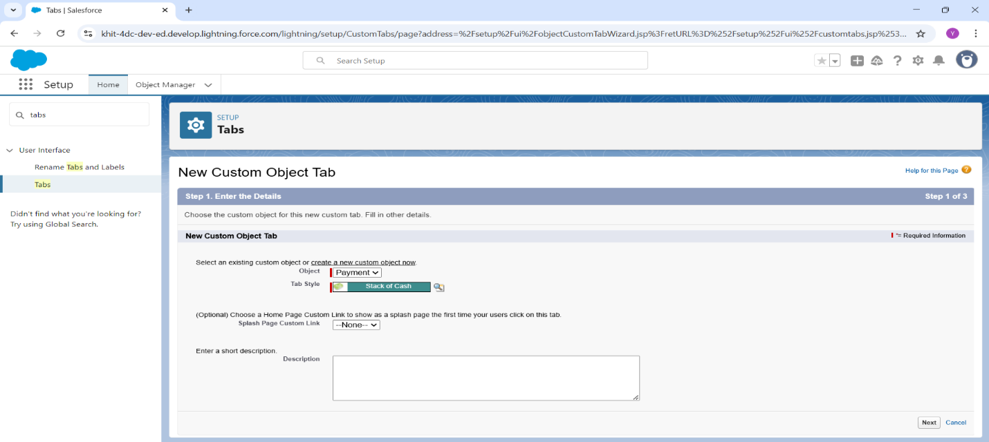

**Relationships**

**Relationships Between Two Objects**

Relationship in Salesforce is a 2-way association between 2 objects. Using relationships, we can link objects with each other and we can make connections and display data about other related objects. Primarily there are two types of relationships:  
**Master detail relationship:** A master-detail relationship defines the relationship between the parent and the child. The master table defines the parent relation and the detail defines the child relation. If the master table is deleted then the child record data is also deleted  
**Look up relationship:** Lookup Relationship in Salesforce links two objects together but has no effect on deletion or security.

**Creation of Relationship Between Visa Slot and Passport**

1. From the Setup page, click on 'Object Manager'.
2. Search and select Visa Slot object.
3. Select Fields & Relations and then click ‘New’.
4. Datatype: Master-detail Relationship
5. Related To: Passport
6. Field Label: Passport Number
7. Field Name: Passport_Number
8. 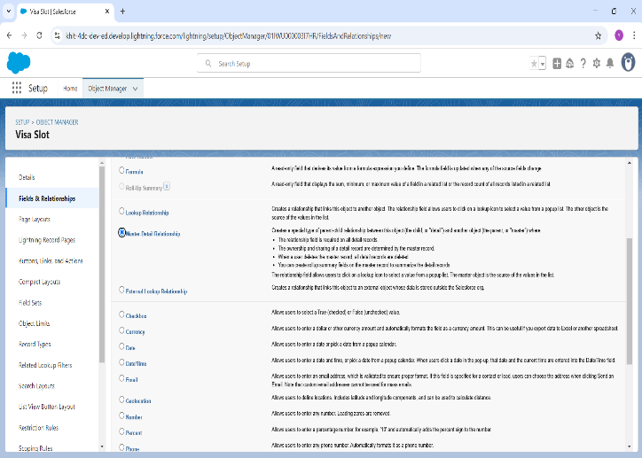Child Relationship: Visa_Slots

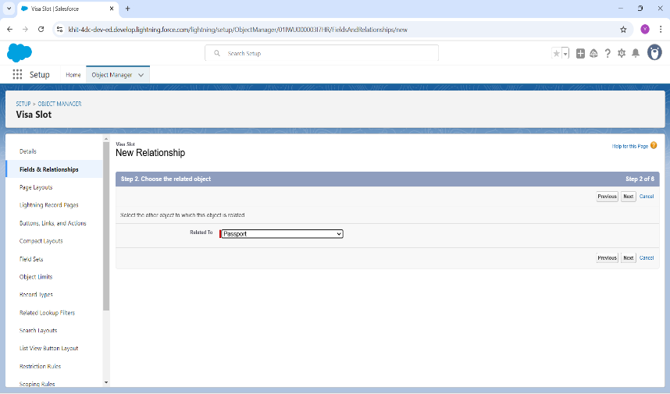

**Fields**

When we talk about Salesforce, Fields represent the data stored in the columns of a relational database. It can also hold any valuable information that you require for a specific object. Hence, the overall searching, deletion, and editing of the records become simpler and quicker.

**Types of Fields**

1. Standard Fields
2. Custom Fields

**Standard Fields:**

As the name suggests, the Standard Fields are the predefined fields in Salesforce that perform a standard task. The main point is that you can’t simply delete a Standard Field until it is a non-required standard field. Otherwise, users have the option to delete them at any point from the application freely. Moreover, we have some fields that you will find common in every Salesforce application. They are,

>>Created By >>Owner >>Last Modified >> Field Made During object Creation

**Custom Fields:**

On the other side of the coin, Custom Fields are highly flexible, and users can change them according to requirements. Moreover, each organizer or company can use them if necessary. It means you need not always include them in the records, unlike Standard fields. Hence, the final decision depends on the user, and he can add/remove Custom Fields of any given form.

**Creation of fields for the Passport object**

**Field: Full Name**

1. Go to the Setup page.
2. Click on 'Object Manager'.
3. Type the object name 'Passport' in the search bar.
4. Click on 'Fields & Relationships'.
5. Click on 'New'.
6. Select the Data Type as 'Text'.
7. Click 'Next'.
8. Fill in the details as follows:
   1. Field Label: Full Name
   2. Field Name: Full_Name
   3. Length: 80
   4. Required: Check the checkbox
9. Click 'Next'.
10. Click 'Next' again.
11. Click 'Save & New' to continue adding more fields.

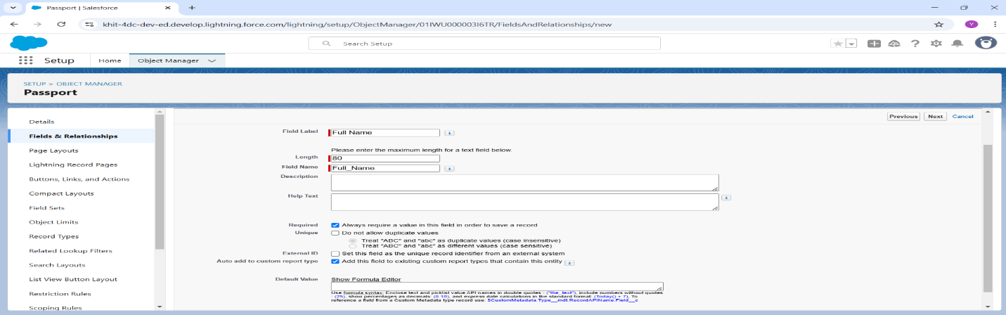

**Field: Contact Number**

1. Go to the Setup page.
2. Click on 'Object Manager'.
3. Type the object name 'Passport' in the search bar.
4. Click on 'Fields & Relationships'.
5. Click on 'New'.
6. Select the Data Type as 'Number'.
7. Click 'Next'.
8. Click 'Next'.
9. Fill in the details as follows:
   1. Field Label: Contact Number
   2. Field Name: Contact_Number
   3. Length: 10 and Decimal: 0
10. Click 'Next'.
11. Click 'Next' again.
12. Click 'Save & New' to continue adding more fields.

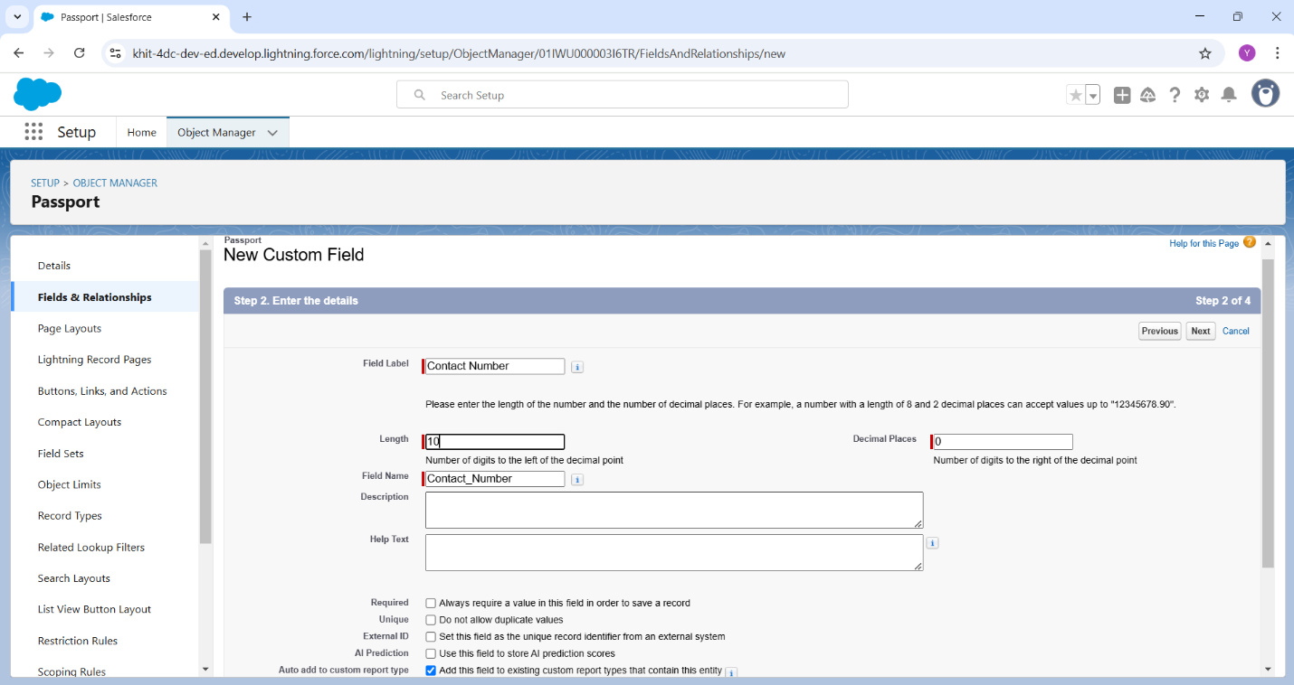

**Field: Permanent Address**

1. Go to the Setup page.
2. Click on 'Object Manager'.
3. Type the object name 'Passport' in the search bar.
4. Click on 'Fields & Relationships'.
5. Click on 'New'.
6. Select the Data Type as 'Text Area'.
7. Click 'Next'.
8. Fill in the details as follows:
   1. Field Label: Permanent Address
   2. Field Name: Permanent_Address
9. Click 'Next'.
10. Click 'Next' again.
11. Click 'Save & New' to continue adding more fields.

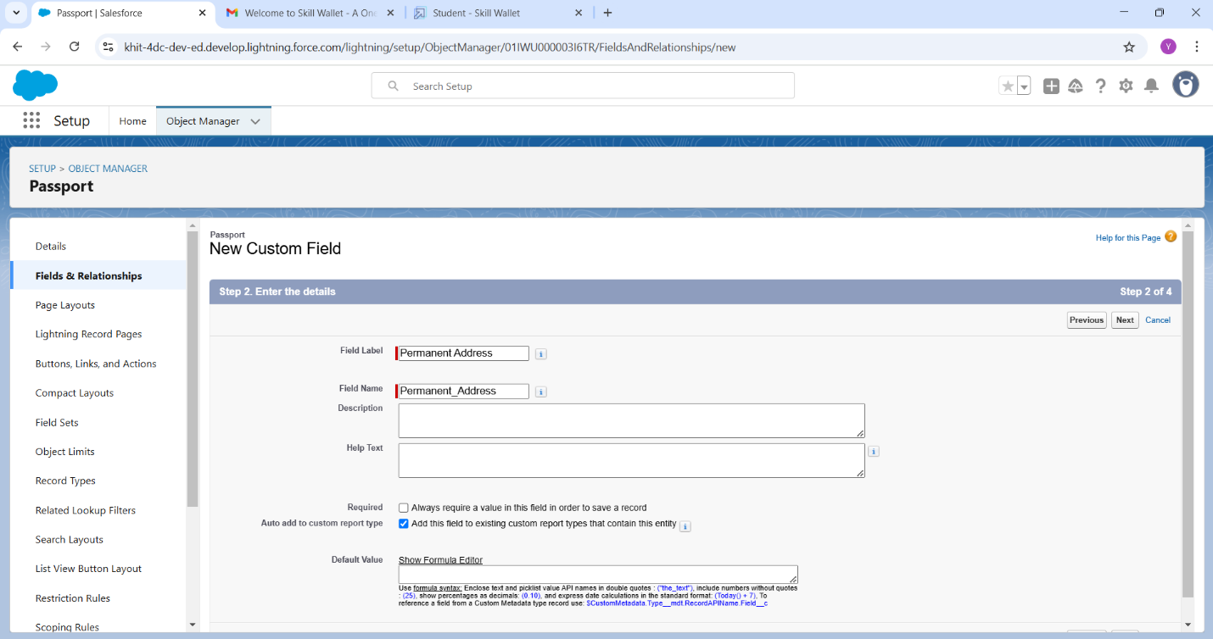

**Creation of fields for the Visa Slot object**

**Field: Location**

1. Go to the Setup page.
2. Click on 'Object Manager'.
3. Type the object name 'Visa Slot' in the search bar.
4. Click on 'Fields & Relationships'.
5. Click on 'New'.
6. Select the Data Type as 'Text'.
7. Click 'Next'.
8. Fill in the details as follows:
   1. Field Label: Location
   2. Field Name: Location
9. Click 'Next'.
10. Click 'Next' again.
11. Click 'Save & New' to continue adding more fields.

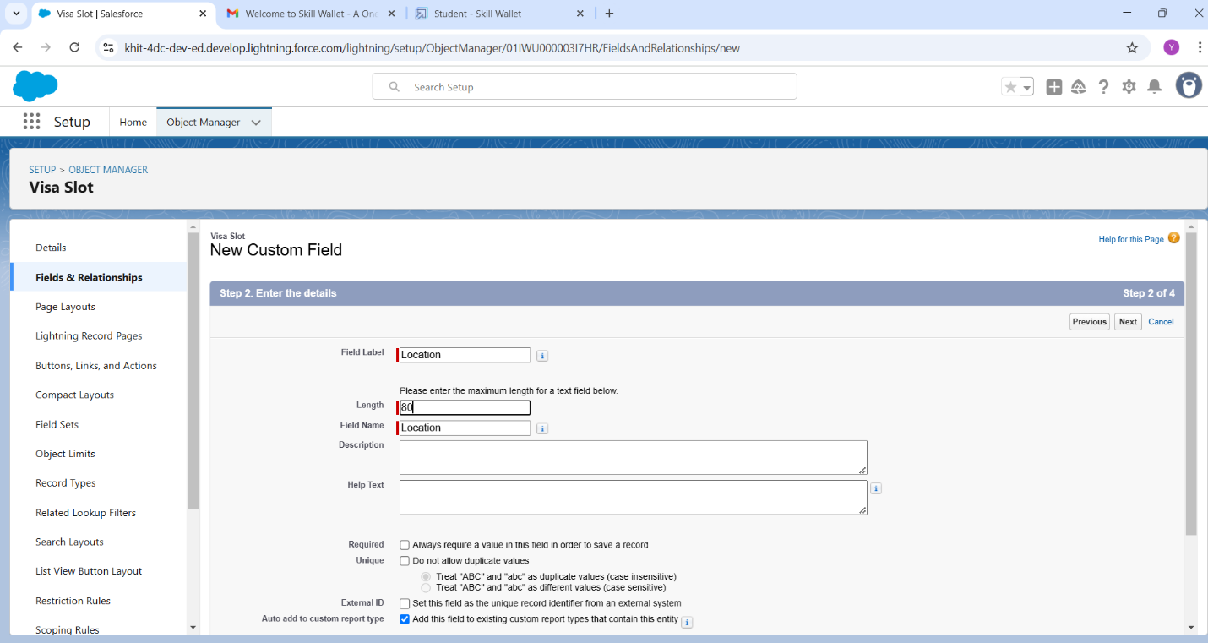

**Field: Time**

1. Go to the Setup page.
2. Click on 'Object Manager'.
3. Type the object name 'Visa Slot' in the search bar.
4. Click on 'Fields & Relationships'.
5. Click on 'New'.
6. Select the Data Type as 'Date&Time'.
7. Click 'Next'.
8. Fill in the details as follows:
   1. Field Label: Time
   2. Field Name: Time
9. Click 'Next'.
10. Click 'Next' again.
11. Click 'Save & New' to continue adding more fields.

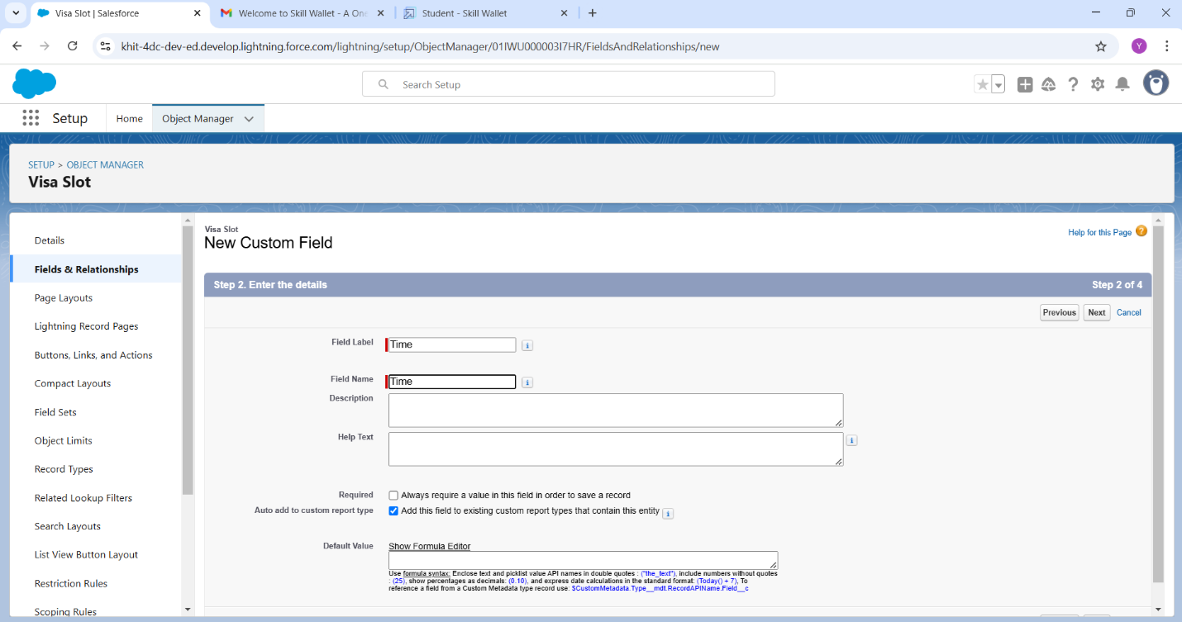

**Field: Status**

1. Go to the Setup page.
2. Click on 'Object Manager'.
3. Type the object name 'Visa Slot' in the search bar.
4. Click on 'Fields & Relationships'.
5. Click on 'New'.
6. Select the Data Type as 'Picklist'.
7. Click 'Next'.
8. Fill in the details as follows:
   1. Field Label: Status
   2. Field Name: Status
   3. Select enter values, with each value separated by a new line
9. Click 'Next'.
10. Click 'Next' again.
11. Click 'Save & New' to continue adding more fields.

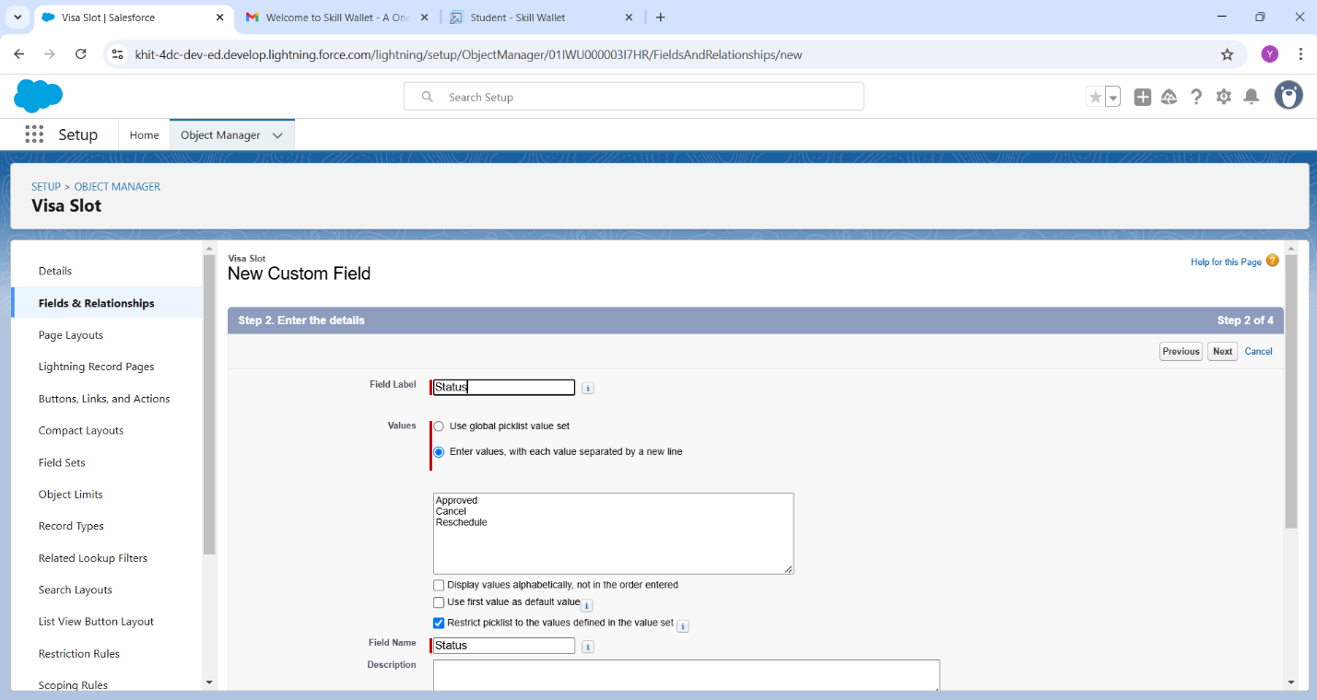

**Creation of fields for the Payment object**

**Field: Payment Mode**

1. Go to the Setup page.
2. Click on 'Object Manager'.
3. Type the object name 'Payment' in the search bar.
4. Click on 'Fields & Relationships'.
5. Click on 'New'.
6. Select the Data Type as 'Picklist'.
7. Click 'Next'.
8. Fill in the details as follows:
   1. Field Label: Payment Mode
   2. Field Name: Payment_Mode
   3. Select enter values, with each value separated by a new line
9. Click 'Next'.
10. Click 'Next' again.
11. Click 'Save & New' to continue adding more fields.

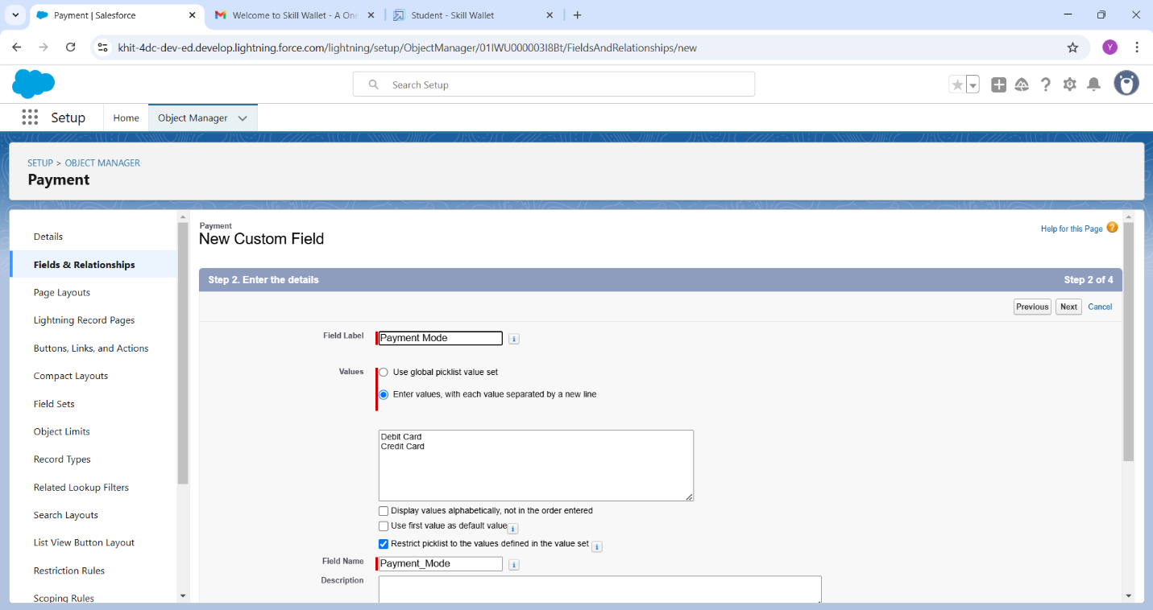

**Field: Card Number**

1. Go to the Setup page.
2. Click on 'Object Manager'.
3. Type the object name 'Payment' in the search bar.
4. Click on 'Fields & Relationships'.
5. Click on 'New'.
6. Select the Data Type as 'Number'.
7. Click 'Next'.
8. Fill in the details as follows:
   1. Field Label: Card Number
   2. Field Name: Card_Number
   3. Consider any length
9. Click 'Next'.
10. Click 'Next' again.
11. Click 'Save & New' to continue adding more fields.

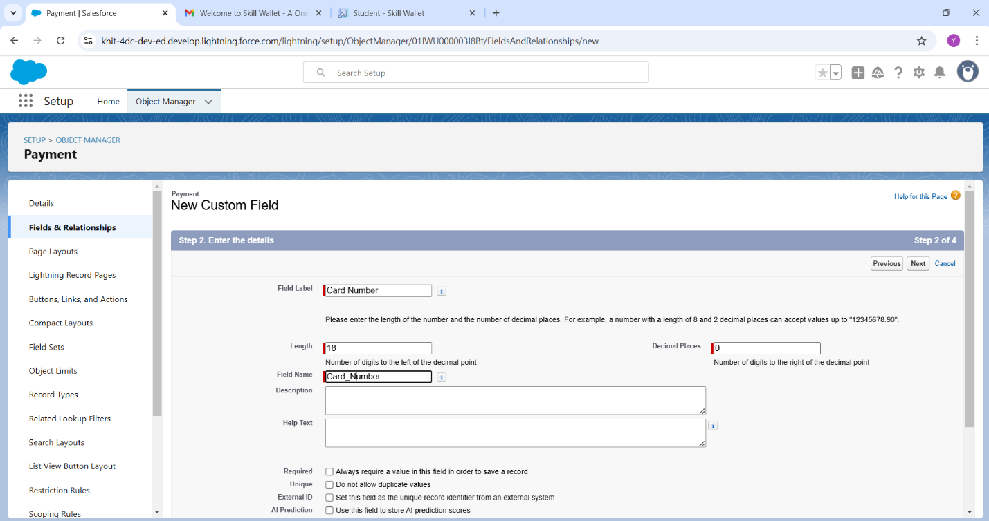

**Field: Visa Slot Number**

1. Go to the Setup page.
2. Click on 'Object Manager'.
3. Type the object name 'Payment' in the search bar.
4. Click on 'Fields & Relationships'.
5. Click on 'New'.
6. Select the Data Type as 'Master-Detail'.
7. Click 'Next'.
8. Related To: Visa Slot
9. Fill in the details as follows:
   1. Field Label: Visa Slot Number
   2. Field Name: Visa_Slot_Number
10. Click 'Next'.
11. Click 'Next' again.
12. Click 'Save & New' to continue adding more fields.

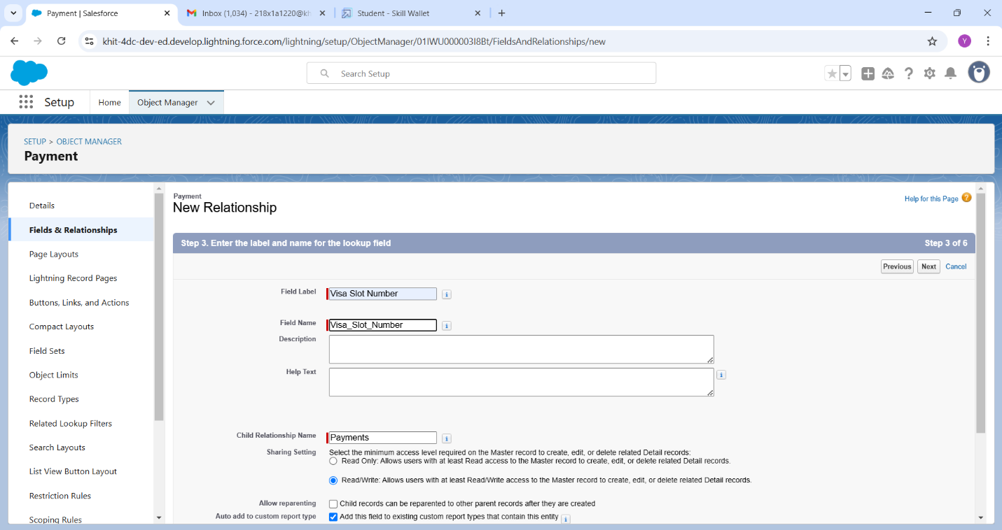

**Field: Cancel Transaction**

1. Go to the Setup page.
2. Click on 'Object Manager'.
3. Type the object name 'Payment' in the search bar.
4. Click on 'Fields & Relationships'.
5. Click on 'New'.
6. Select the Data Type as 'Text'.
7. Click 'Next'.
8. Fill in the details as follows:
   1. Field Label: Cancel Transaction
   2. Field Name: Cancel_Transaction
   3. Consider any length
9. Click 'Next'.
10. Click 'Next' again.
11. Click 'Save & New' to continue adding more fields.

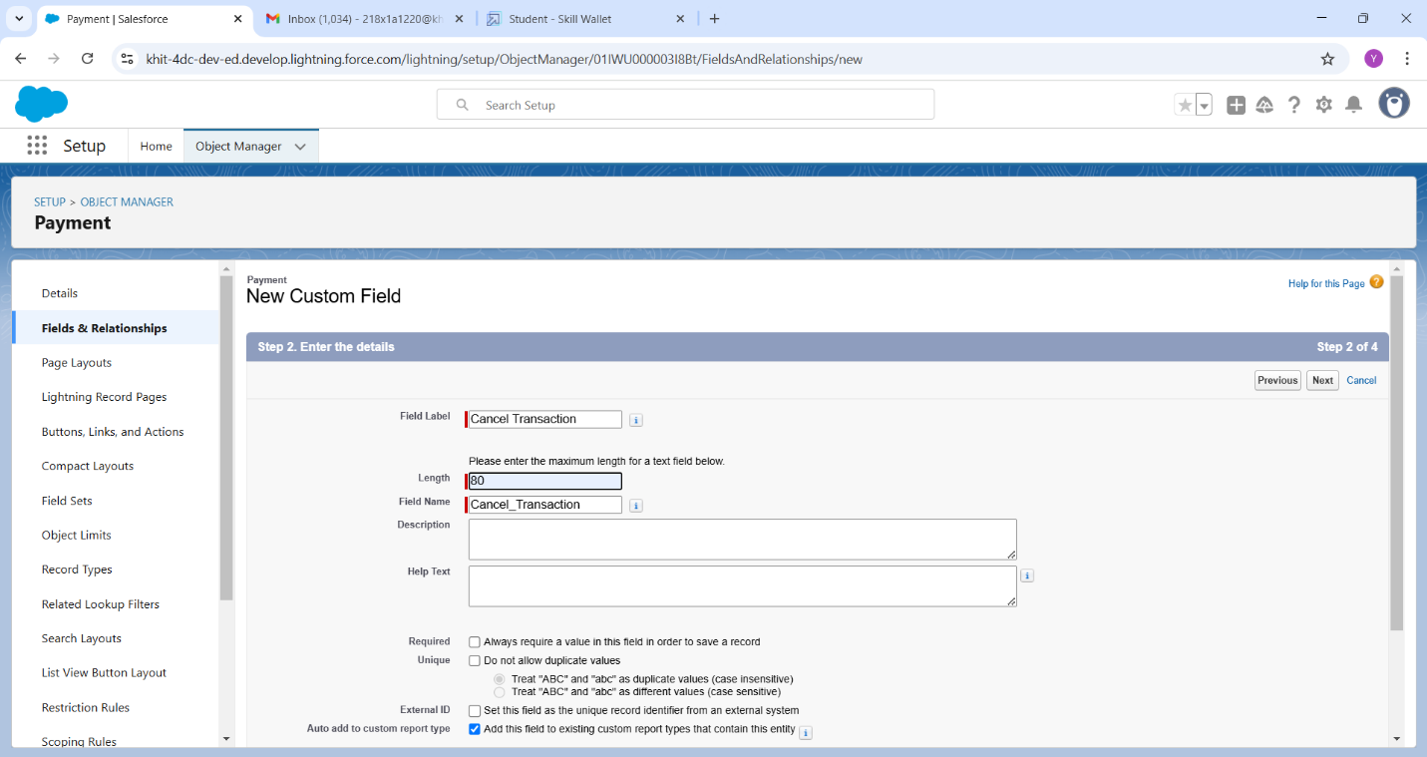

**The Lightning App**

An app is a collection of items that work together to serve a particular function. In Lightning Experience, Lightning apps gives users access to sets of objects, tabs, and other items all in one convenient bundle in the navigation bar.

Lightning apps let you brand your apps with a custom color and logo. You can even include a utility bar and Lightning page tabs in your Lightning app. Members of your org can work more efficiently by easily switching between apps.

**Creation of Book My Visa App**

1. Search for 'App Manager' in the Quick Find bar and select 'App Manager'.
2. Click on 'New Lightning App'.
3. Fill in the app details and branding as follows:
   * App Name: Book My Visa
   * Developer Name: Book_My_Visa
   * Primary Colour Hex Value: Keep as default

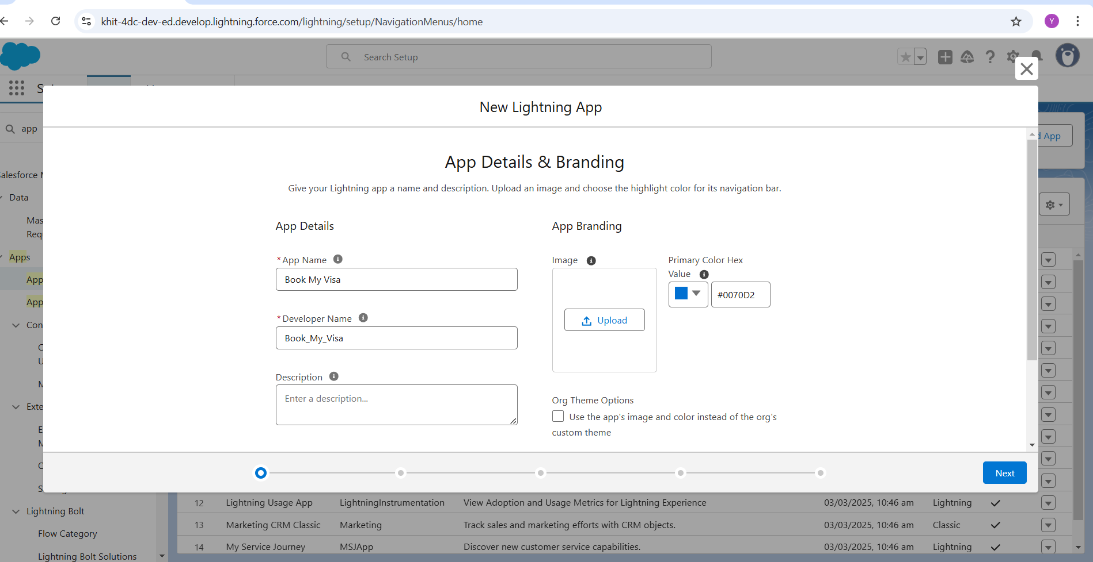

1. Click 'Next'.
2. On the 'App Options' page
3. Navigate System: Standard Navigation
4. Support Form Factor: Desktop and Phone
5. Click 'Next'.
6. On the 'Utility Items' page, keep it as default.
7. Click 'Next'.
8. To Add Navigation Items:
   * Search for the items (Passport, Visa Slot, Payment) in the search bar.
   * Move the selected items using the arrow button.
   * Click 'Next'.

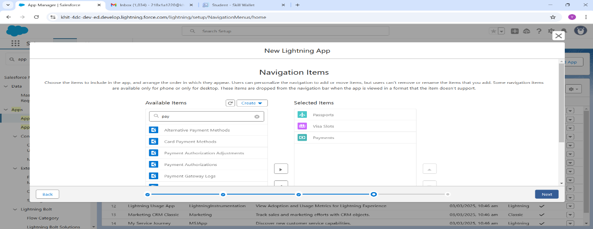

1. Click 'Next' again.
2. To Add User Profiles:
   * Search for 'System Administrator' in the search bar.
   * Click on the arrow button to add it.
   * Click 'Save & Finish' to complete the setup.

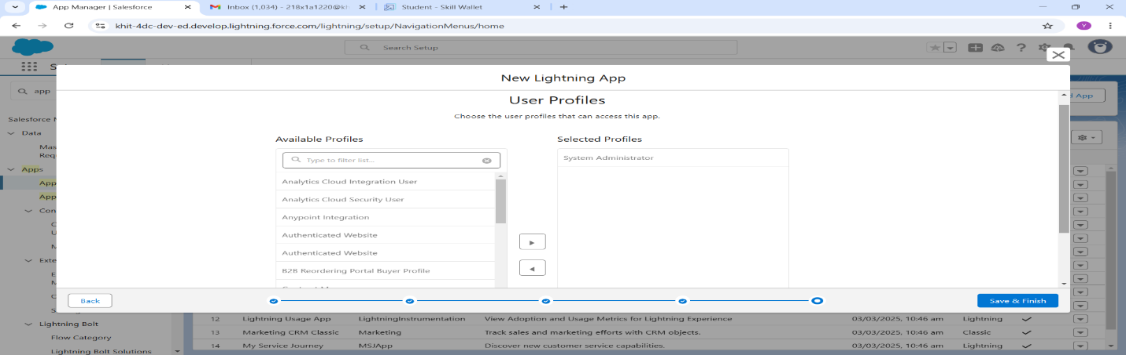

**User Creation**

1. Navigate to setup
2. In Quick Find box select and search: User
3. Click: New user
4. Give First and Last Name
5. Enter your email in the email field
6. Enter user name, it must be unique
7. User license: salesforce platform
8. In the profile field: Standard user profile
9. Select Generate new password and notify user immediately and save

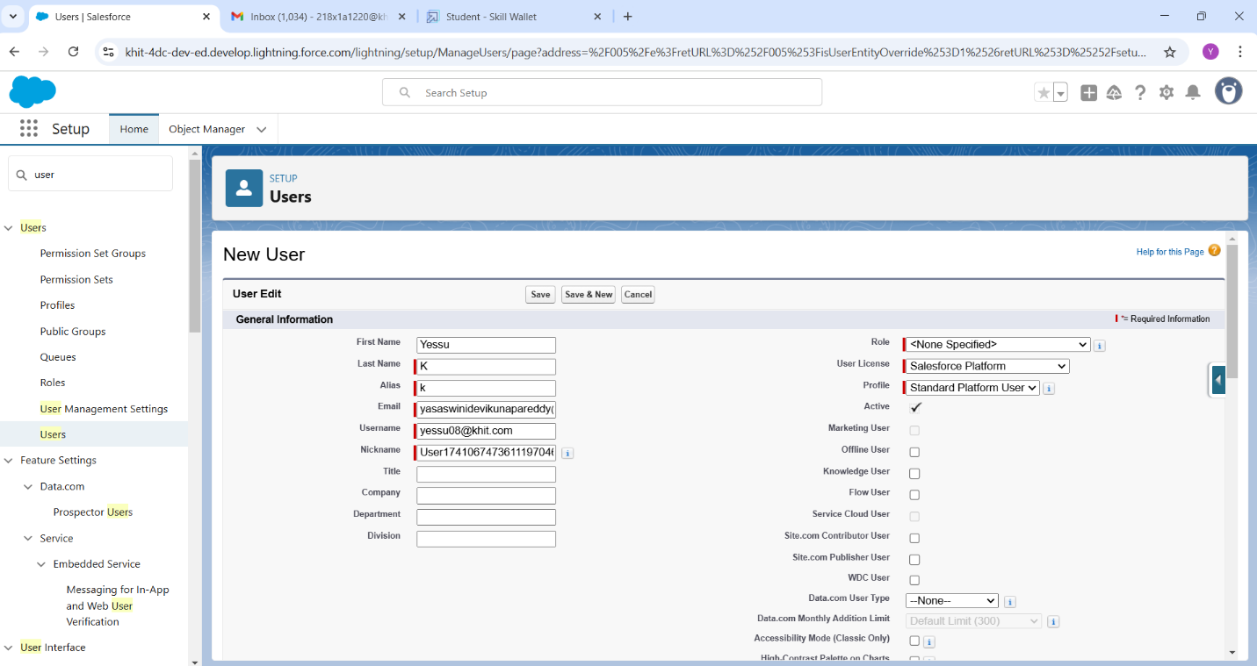

**Organization Wide Defaults Settings**

OWD settings can be used to give permission to the organization wide and it can be used for restrict the access; we can control the record level access.

Primarily four types of access can be set in Salesforce OWD-

1. Public read/write/transfer (Only available for Leads and Cases)
2. Public read/write
3. Public read only
4. Private

Steps of OWD settings

1. Navigate setup in Quick Find search bar
2. Type Sharing Setting and Select it.
3. Edit: Organization Wide Defaults.
4. Scroll down list and select Passport object and change the default external Access to Public Read/Write.
5. Save.

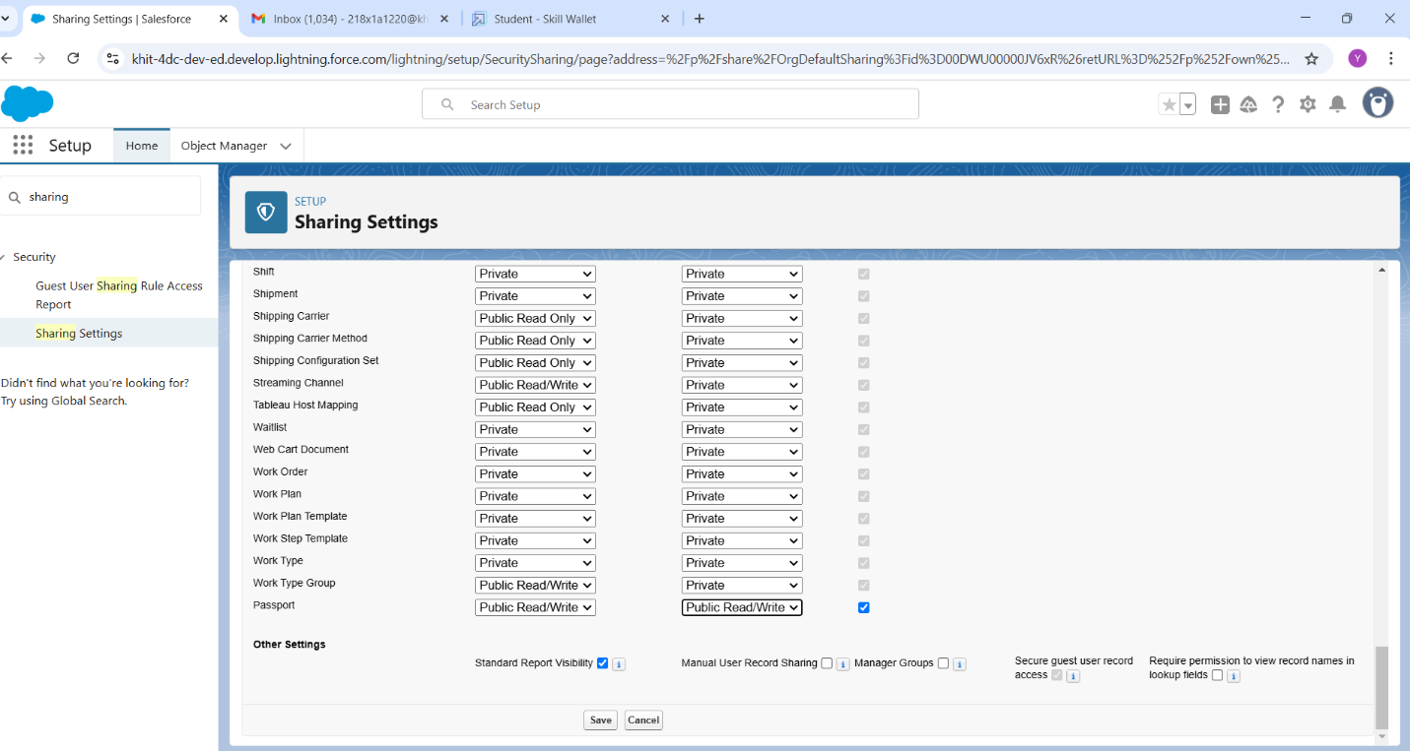

**User Adoption**

1. Create records on passport object
2. View Records
   1. Click on App launcher
   2. Search Book My Visa & click on it
   3. Click on Passport Tab
   4. Click on any of the record to view the record

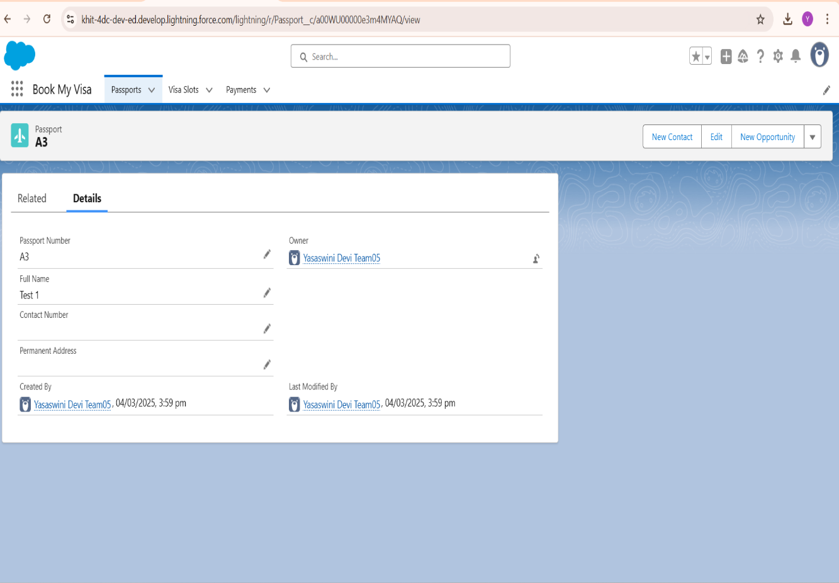

1. Delete Records
   1. Click on App launcher
   2. Search Book My Visa & click on it
   3. Click on Passport Tab
   4. Click on arrow at right hand side on that particular record you want to delete
   5. Click delete and delete again

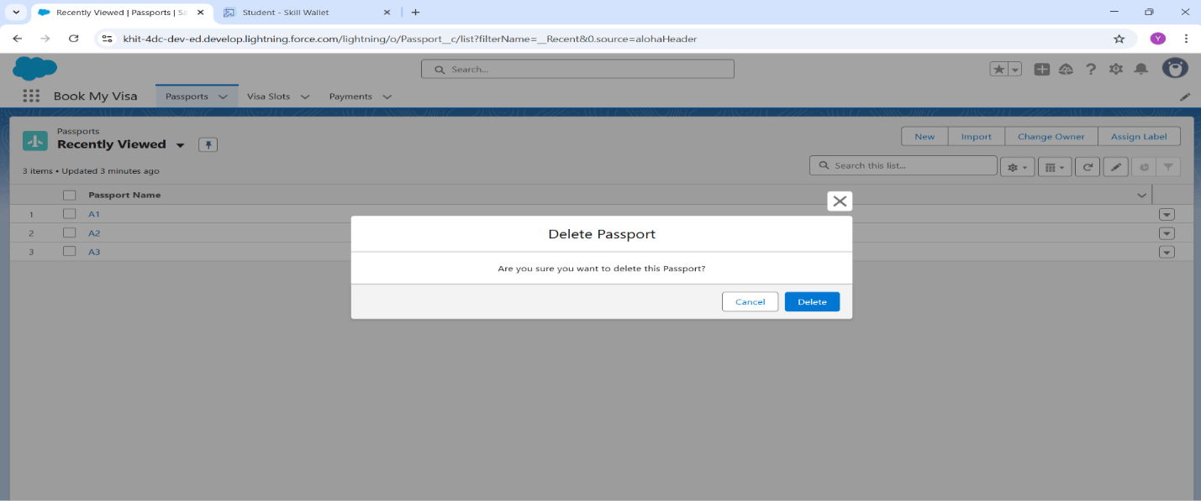

**Reports**

Reports in Salesforce is a list of records that meet a particular criterion which gives an answer to a particular question. These records are displayed as a table that can be filtered or grouped based on any field.

**Creation of Report**

1. Click on App Launcher left side on the screen, Search and select: Report
2. Click Report- select New Report
3. Select Report Type: Passport with Visa Slot Number
4. Click on Start Report button
5. Below the Outline pane- In the Group Row select: Location
6. In Group Column select- Passport: Passport Number
7. In Column select: Visa Slot Number
8. Now navigate to Filter pane available next to Outline pane and ensure in the show me section: All Passport is selected
9. In Passport Created date: All Time.
10. Give the Label: Passport with Visa Location.
11. Save & Run for saving the Report.

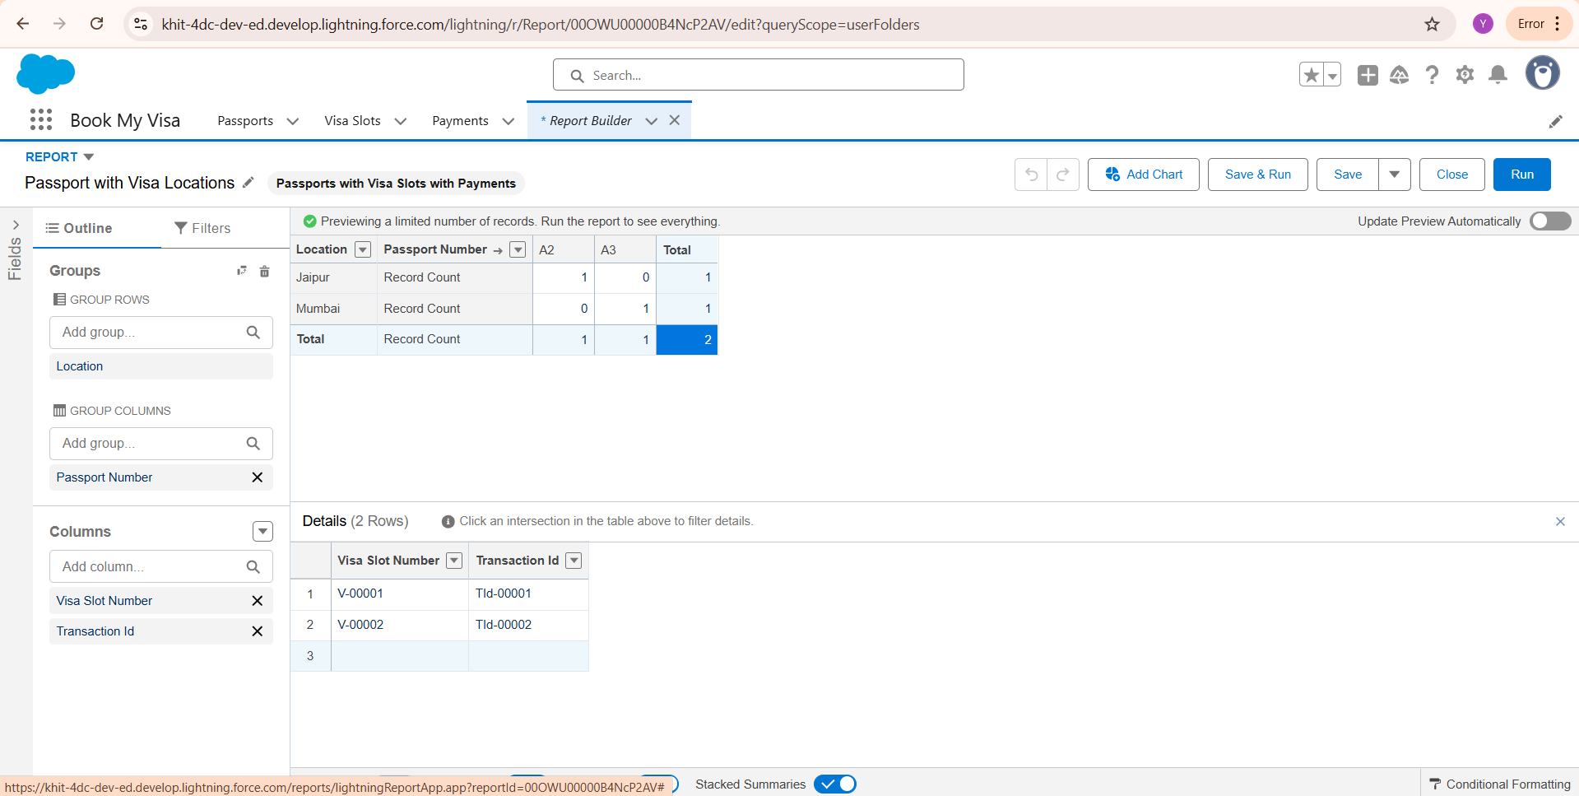

**View Report**

1. Click on App Launcher on left side of screen.
2. Search Book My Visa App & click on it.
3. Click on Reports Tab.
4. Click on Passport with Visa Location and see reports.

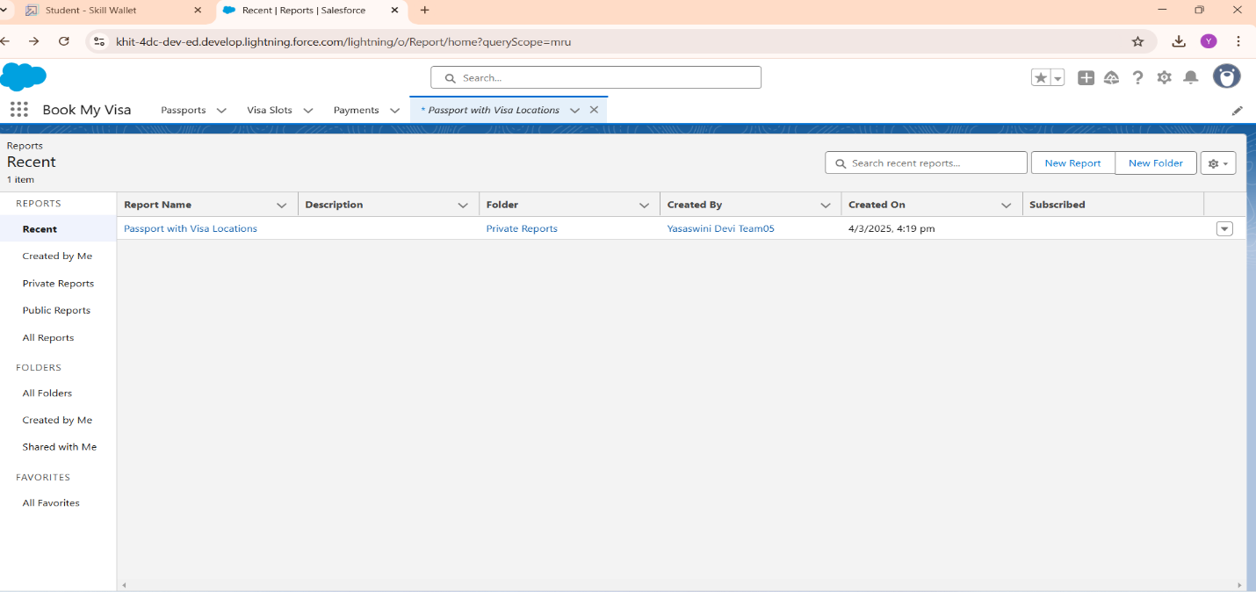

**Dashboards**

Dashboards in Salesforce are a graphical representation of Reports. It shows data from source reports as visual components.

**Creation of Dashboard**

1. Click on the App launcher left on screen and search for dashboards.
2. Select New Dashboard
3. Name the Dashboard: Passport With Visa Location
4. Select Create option
5. Click on Add Component
6. Select Passport with Visa Locations
7. Click Select
8. Select the Donut Chart to display a section
9. Value: Record count
10. Sliced By: Location
11. Leave the default values
12. Click on Add
13. Save the Dashboard and Done.

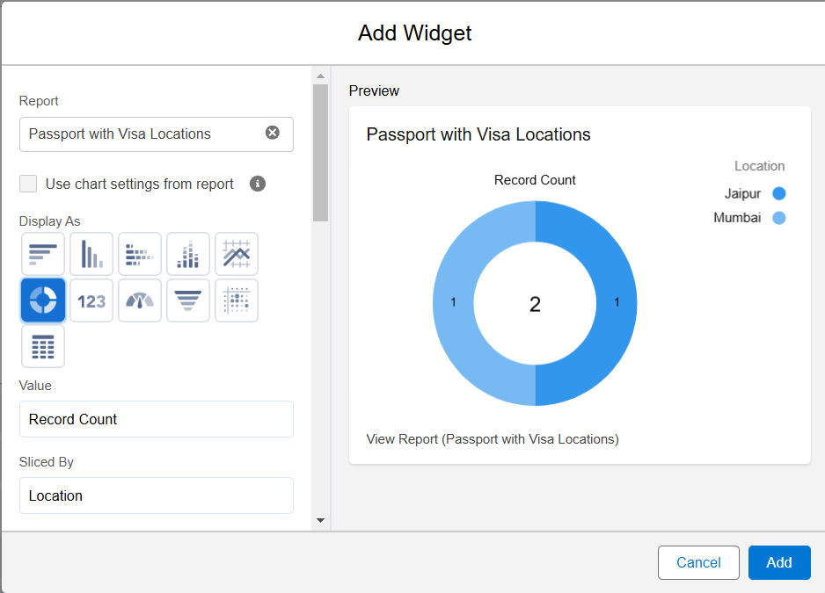

**View Dashboard**

1. Click on App Launcher on left side of screen.
2. Search Book My Visa & click on it.
3. Click on Dashboard Tab.
4. Click on Passport with Visa Location see graph view of records

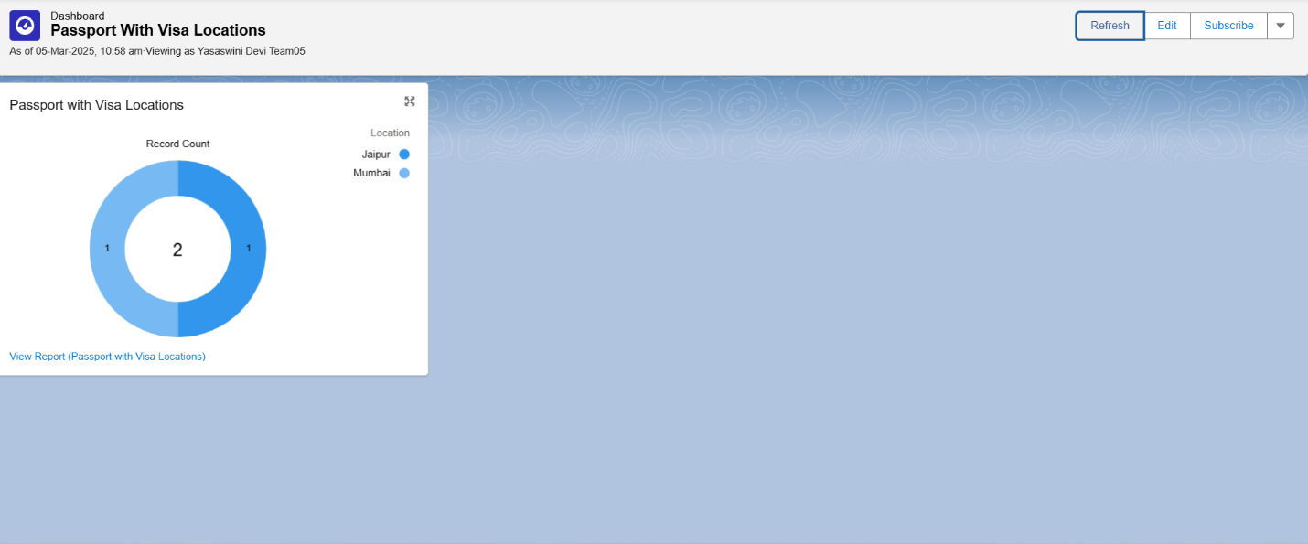

**Apex Triggers**

A trigger is a set of Apex code that runs before or after data manipulation language (DML) events.

There are two Salesforce Apex trigger types:

**Before triggers:** These are helpful in cases that require a validation process before accepting a change. They run before any database changes.

**After triggers:** These are helpful in cases where you need to modify your database records and when the necessary value is stored in other records. They run after any database changes.

**Trigger-1**

1. Click on Set up Gear at drop down list you can find developer console click on that.
2. At the left side top you can find the option new click on that and then apex trigger.
3. Give the name as Deletionofvisarecord
4. And S object has Visa Object

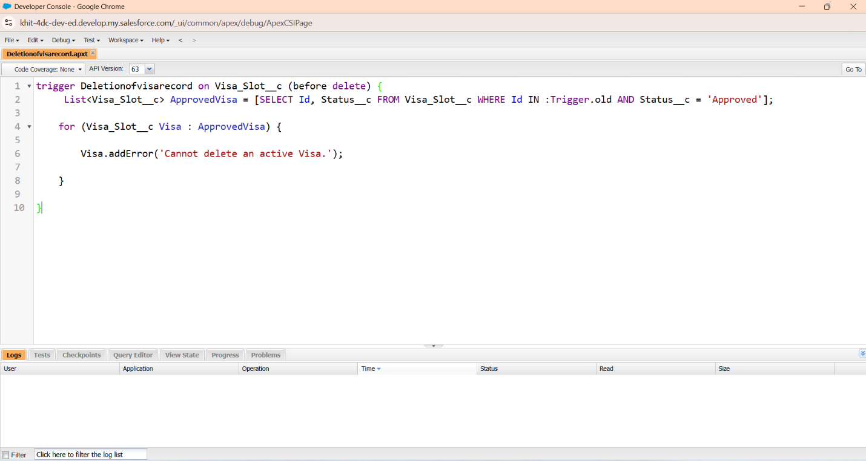

**Trigger-2**

1. Click on Set up Gear at drop down list you can find developer console click on that.
2. At the left side top you can find the option new click on that and then apex trigger.
3. Give the name as AvoidDuplicatePassport
4. And S object has Passport Object

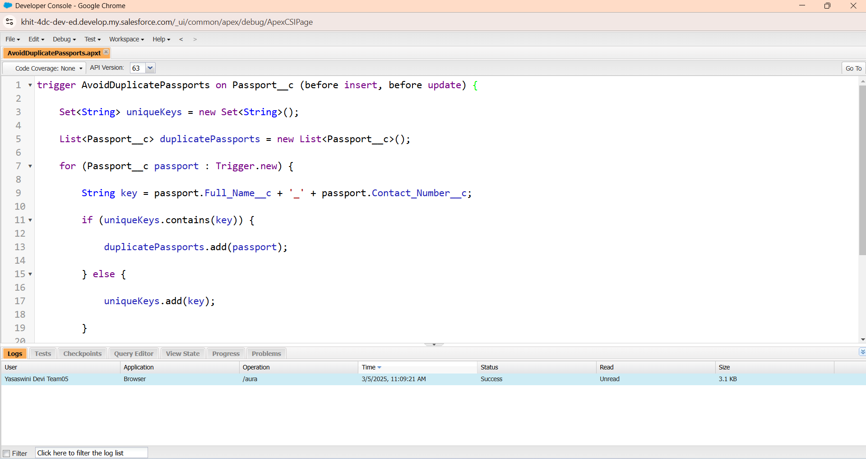

**Testing and Validation**

**Custom Objects**

**Visa Applicant:** Stores applicant details and visa type information.

**Visa Slot**: Tracks available appointment slots.

**Visa Agent:** Manages and assists applicants with booking.

**Embassy:** Logs embassy details and processing timelines.

**Slot Booking**: Manages appointment booking details for applicants and agents.

**Reports and Dashboards**

**Slot Availability Report:** Displays available slots for booking.

**Visa Application Status Report:** Tracks application progress.

**Booking Efficiency Dashboard:** Analyzes successful appointment scheduling.

**Automations**

**Slot Confirmation Notifications:** Sends alerts upon successful booking.

**Appointment Reminders:** Notifies users about upcoming slots.

**Auto-Assignment of Agents**: Assigns visa agents to assist applicants. Outcomes

**Efficient Visa Slot Booking**: Reduces delays by providing structured appointment management. **Improved User Experience:** Enhances applicant satisfaction through better scheduling.

**Data-Driven Decision Making**: Provides insights on visa processing trends and booking efficiency.

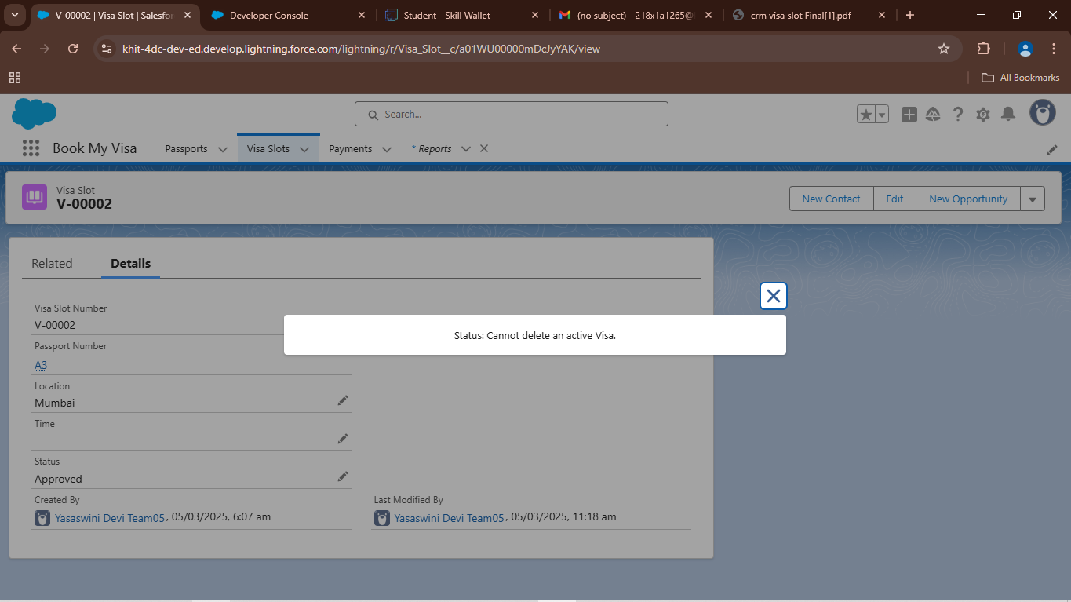

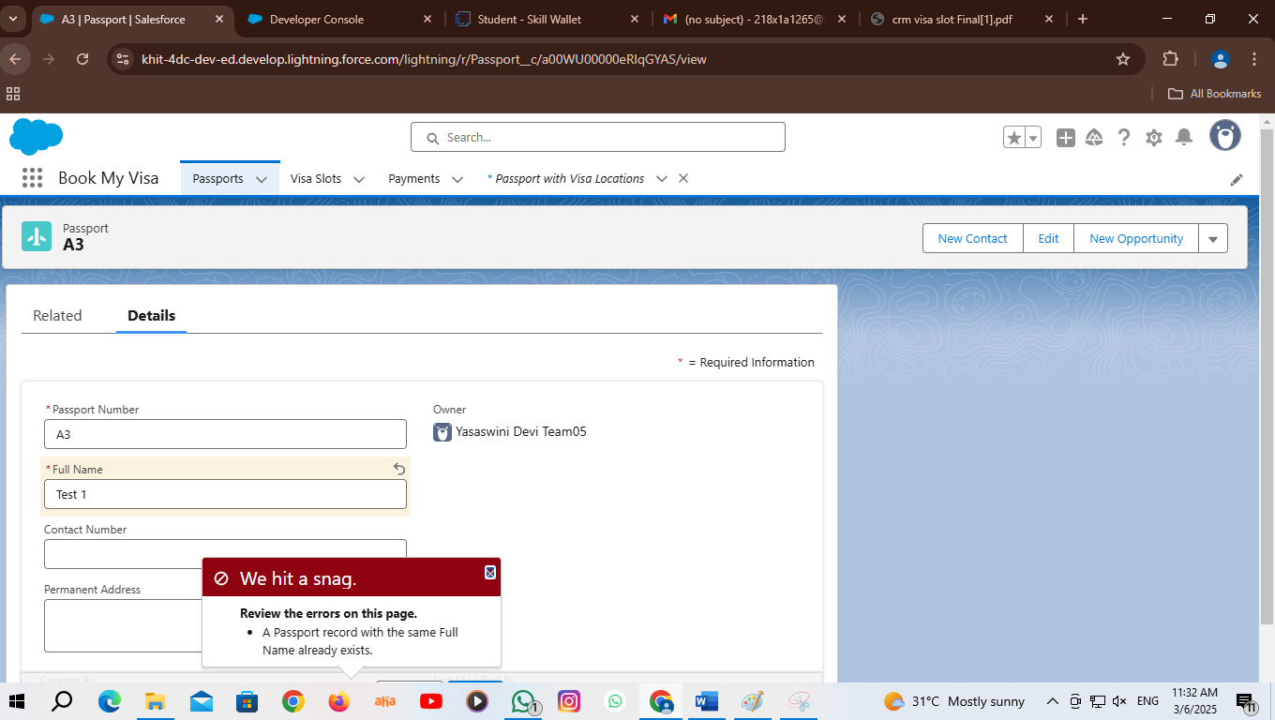

**Use Case Scenarios in Daily life**

**1.Student Visa Application:** A student planning to study abroad books a visa appointment through the CRM system, receives reminders, and gets updates on document submission requirements.

**2.Business Travel Scheduling:** A business professional schedules a visa slot for an urgent work trip, ensuring minimal delays through real-time slot tracking

**3.Embasssy workload Management:** The system helps embassies manage high volumes of visa applications by optimizing available slots and sending automated updates.

**Challenges and Solutions**

**Challenge:** High demand for limited slots

**Solution:** Implemented automated scheduling & waitlists

**Challenge:** Real-time slot updates

**Solution:** Integrated a live booking calender

**Challenge:** Communication with applicants

**Solution:** Created automated notifications & reminders

**Conclusion**

The CRM-based visa slot booking system successfully optimizes the visa application process by providing a structured, automated appointment scheduling system. By leveraging Salesforce CRM, automated notifications, and real-time scheduling, the system streamlines operations, making visa slot booking more efficient and user friendly. The proposed enhancements, including a mobile application and AI-driven analytics, will further improve efficiency and scalability in the future.

**Thank You**